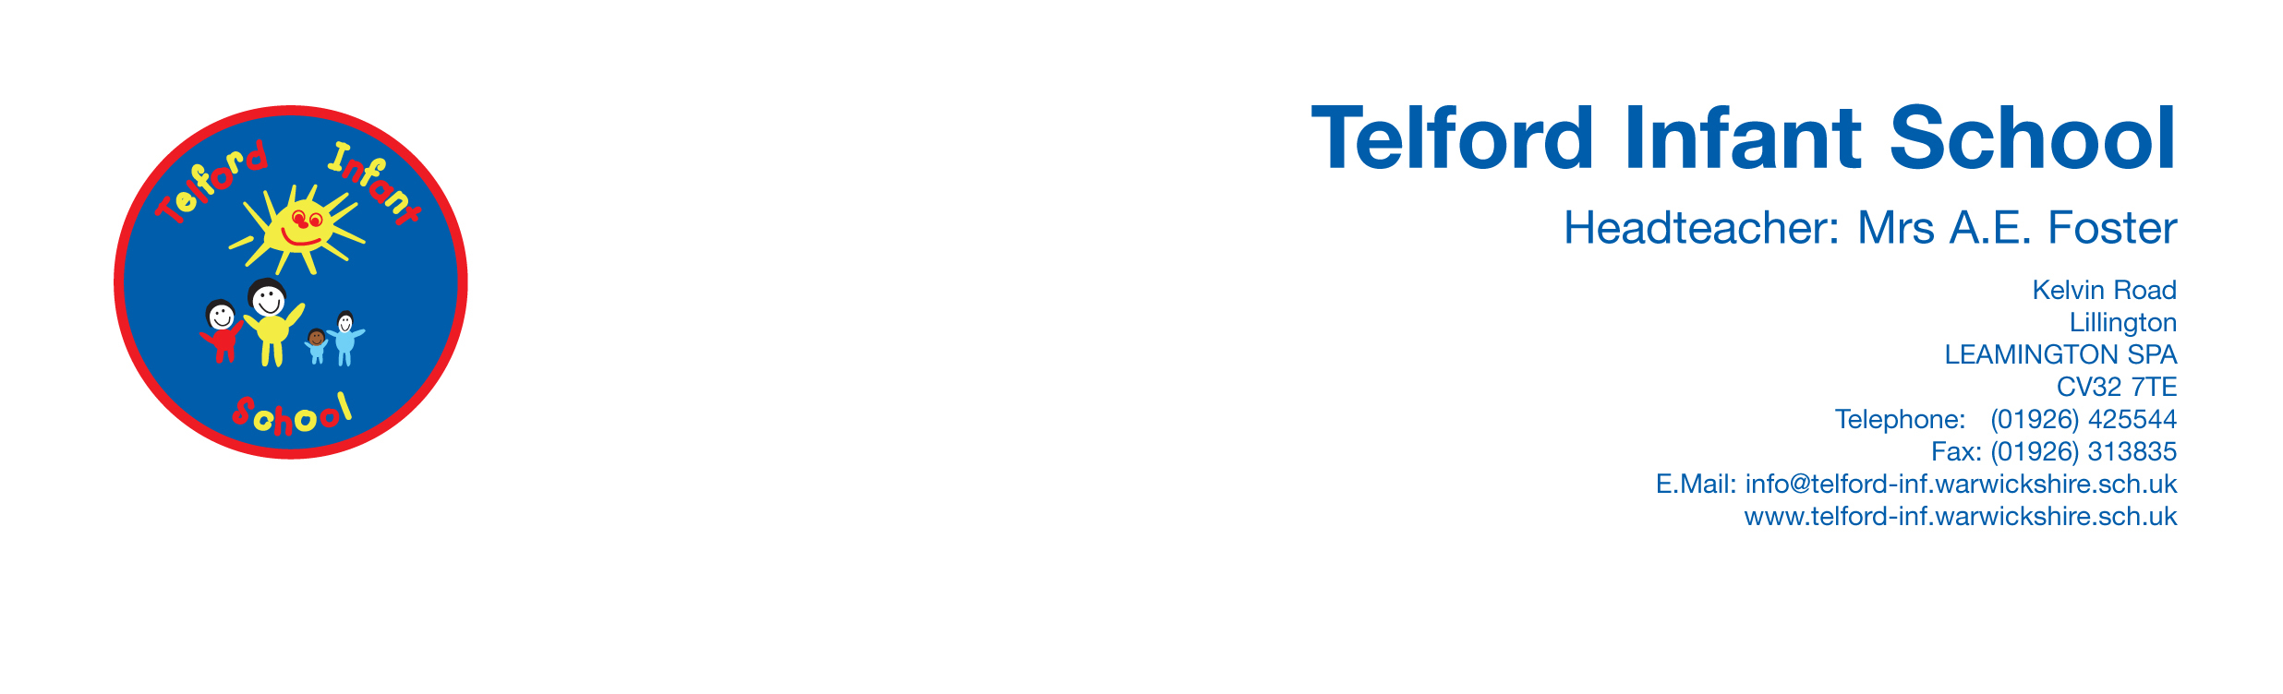

School Council Meeting Minutes 17/11/25
Indigo – Elke, Ronan
Turquoise - Max, Rozaylia
Sapphire – (Teddy), Isla
Amber – Leonardo, Cali
Sunshine – Alessandro, Iris
Primrose – Florence, Nate
Our Purpose
We are the voice of the students
- We aim to get things done to make our school better.
- To find ways to improve our school.
- To give every pupil a voice and to make all decision making fair.
Welcome to all new school councillors. Please take your letter home and get it signed by your parents and bring back to Mrs Walsh next week.
Children in Need
Thank you for your amazing donations we have raised approximately £413.00
Updates and questions for your class this week.
Don’t forget to complete your class 25 laps challenge this week !

