ENGLISH:  In English, we shall become familiar with Julia Donaldson as an author and will read some of her most famous stories such as The Gruffalo, Monkey Puzzle and Zog. We will use these stories to help the children sequence events, make predictions, describe characters and retell the plot in their own words. We will find out about Julia Donaldson herself using non-fiction texts and the internet. We will also be exploring rhythm and rhyme through reading and reciting poetry.  Phonics will be taught daily. | MATHEMATICS:  In Maths this term, we will be counting, representing, comparing and ordering numbers, including using the comparing symbols < > and =. The children will continue to learn about the part part whole model, recording number facts as number sentences and recalling the number bonds to 10. At the end of the term we will be adding number within 10, including using number lines. They will continue to learn through our mastery approach, using a range of resources and activities inside and outside the classroom. | SCIENCE:  In Science, our topic will be ‘Terrific Trees’ and the children shall be identifying and naming common trees. They will explore the differences between evergreen and deciduous trees. We shall look at the basic structure of trees and find out what the different parts are for.  We will use the school grounds to observe and identify the variety of trees growing there. We will learn about our key scientist Carl Linnaeus. Throughout the sessions, we will have a clear focus on the science skill of observing. | COMPUTING:  In Computing the children will be taught to safely use a range of apps on our class Ipads. These apps will reinforce and extend our learning in many areas of our curriculum. We shall use 2paint to create pictures of story characters, play phonics and maths games and complete research using the Julia Donaldson website.
SPELLING, PUNCTUATION, GRAMMAR:  The children will learn how to write a perfect sentence with capital letters, finger spaces and full stops. They will revise the phase 2 and 3 tricky words and start learning how to spell the Year 1 common exception words.  HANDWRITING:  The children will recap how to hold a pencil using a tripod grip and then learn how to form the following letters correctly:  c a o d g q s e f  We will focus on the letter c as the starting point for these letters and on producing letters of an appropriate size. | Year 1 Autumn Term 1 2025  The Wonderful World of Julia Donaldson  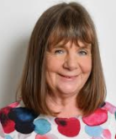  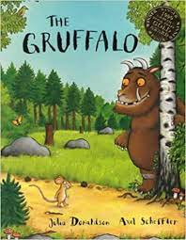  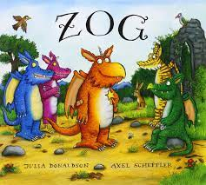 |  | PSHE:  In PSHE we will start the new year by discussing why ‘Rules Matter’ and learning the school rules that are in place to ensure we all are safe and happy in school. Children will have opportunities to appreciate and celebrate differences and similarities between themselves and to experience how supportive it feels to belong to, and be valued by, the class group. They will have opportunities to develop empathy for others and think of ways to support them.
ART and DESIGN & TECHNOLOGY:  In Art the children will be making colourful paintings linked to their learning about Julia Donaldson’s characters. They will focus first on mixing primary colours to make secondary colours and using different brushes to get different effects. They will then learn about the sculptor Yayoi Kusama and use clay to create their own pumpkins.  Throughout the half term they will have opportunities to use Design & Technology skills in classroom provision, for example designing homes for Gruffalo characters and cutting, shaping and joining materials. | PE:  The focus of our PE lessons this half term is Games and in particular throwing and catching. The children will be learning to:  - track and receive a ball  - throw underarm  - catch an object by themselves  - throw and catch an object with a partner  - bounce a ball on a spot  - throw, bounce and catch an object. | MUSIC:  In Music, we will be singing, listening and composing, with a focus on pitch. We will choose sounds to represent the different characters in The Gruffalo and compose voice chants and short musical pieces for these characters too.  RE:  Our first enquiry question is: “How might your worldview be seen in the choices you make?” We will explore the Golden Rule which is common to many different religions and worldviews. Thinking further about Christianity we will prepare for the Harvest Festival at St Mary’s Church. | GEOGRAPHY:  We will look at maps and start to locate places of interest, for example places we have visited and where Julia Donaldson lives. We will also look at seasonal changes and Autumn weather patterns.  HISTORY:  After learning about family trees and timelines we will talk about what was different when our parents and grandparents were younger. We will find out about Julia Donaldson’s life and in particular the toys she played with when she was young. We will compare these to the toys the children play with now.

